Vehicle Incident data analysis Report

Result

## Speed Limit and Vehicle Damage Extent

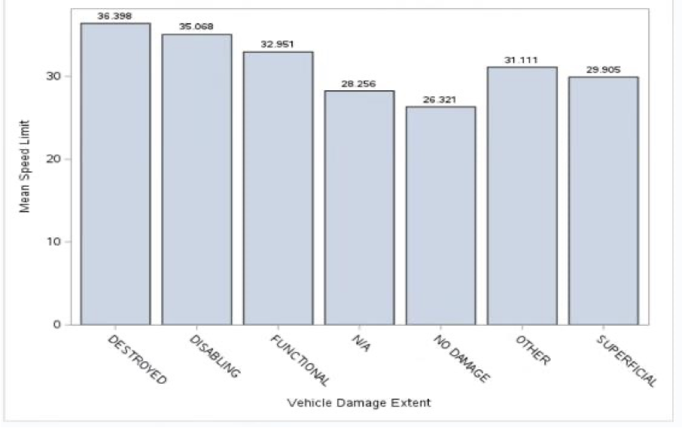

Figure Speed limit - Vehicle Damage Extent

The level of the vehicle damage is classified in the dataset as "destroyed" or "no damage," and the mean speed restrictions of the various locations are noted. As speed restrictions rise, there is a discernible trend towards more serious damage to automobiles, such as being "destroyed" or "disabled." The mean speed limit is regularly at its lowest when cars show "no damage," on the other hand. This fascinating trend highlights the lowest speeds in the dataset that are related with undamaged automobiles while highlighting a relationship between higher speed restrictions and increasing vehicular damage.

## Light type and vehicle damage extent

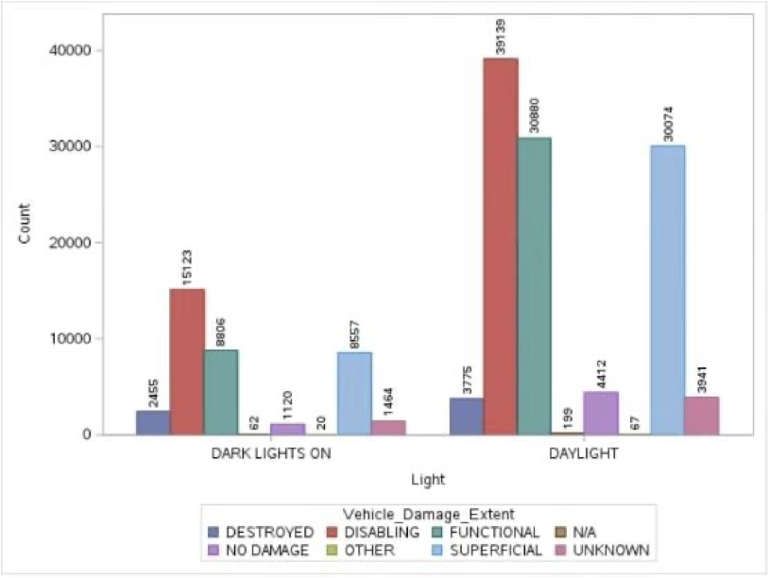

Figure Light typle - Vehicle damage extent

The collection is made up of boolean values that represent two sorts of illumination conditions: "dark lights on" and "daylight." The investigation involves comparing the counts of different vehicle damage extents under these diverse illumination situations. Interestingly, while the number of occurrences occuring in daylight and dim illumination vary greatly, the distribution of damage extent appears to be relatively comparable across different settings. This shows that the kind of lighting may not have a direct influence on the degree of vehicle damage, as damage extent distribution patterns remain constant whether accidents occur in daytime or at night.

## Hit and Run and Responsibility

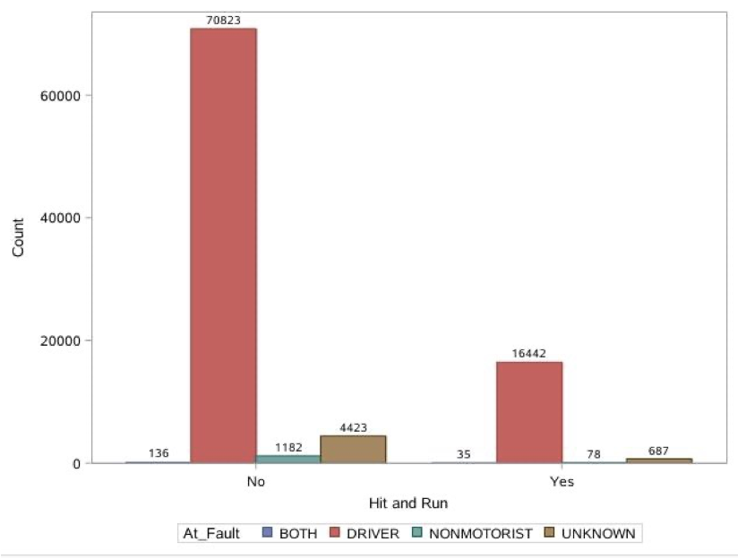

Figure Hit and Run - Responsibility

A boolean variable was employed in this study to determine if the occurrence was a hit and run. The variable indicating who was to blame was then investigated. Surprisingly, the statistics indicated a consistent tendency in both scenarios: the driver was almost always at fault. Surprisingly, a sharp discrepancy occurred when cases were classified as hit and runs. In these cases, the non-motorist was almost never found to be at blame. This study emphasises the unique nature of hit-and-run incidents, which are frequently marked by a lack of accountability on the side of non-motorists and a heavier burden on drivers.

## Hit and Run to the relation of Alcohol

Figure Hit and Run - Driver Substance Abuse

This chart provides an overview of incidents involving Hit and Run, categorized based on the Driver substance abuse variable, with a specific focus on the presence of alcohol. The purpose of this chart is to underscore the correlation between Hit and Run incidents and alcohol abuse. While the number of Hit and Run cases is notably lower than that of regular incidents, it's noteworthy that a significantly higher proportion of these cases involve alcohol abuse (9%) compared to regular cases (2.7%).

This data indicates that the likelihood of alcohol abuse occurring in Hit and Run cases is more than three times greater than in regular cases. This observation raises significant concerns regarding the impact of alcohol on drivers' ethical decision-making processes and its potential to exacerbate the occurrence of Hit and Run incidents. The data strongly suggests that addressing alcohol abuse among drivers is imperative in reducing the frequency and severity of Hit and Run incidents, as it appears to be a prominent contributing factor. Further research and preventative measures should be considered to address this concerning trend and promote safer roadways for all.

## Mean speed limit and road condition

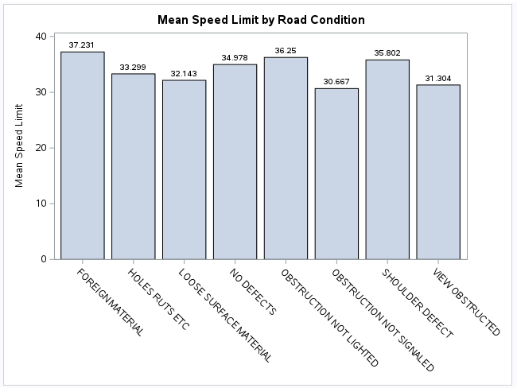

Figure Mean of Speed Limit - Road Condition

The graph depicts speed limit variations based on different road conditions. Remarkably, the highest mean speed limit of 37.231 is observed when foreign materials are present on the road. In contrast, the lowest mean speed limit is associated with obstructed views, particularly when no signals are in place (30.667), and when views are obstructed by 31.304. Notably, road conditions with unlit obstructions show a mean speed limit of 36.25, while road conditions with shoulder defects exhibit a mean speed limit of 35.802, surpassing road conditions with a mean speed limit of 34.978.

## Injury Severity and Vehicle Damage Extent

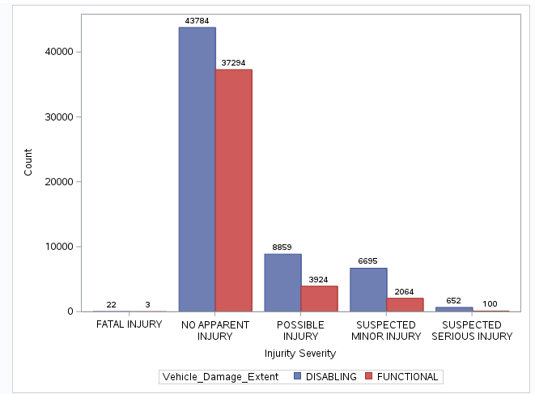

Figure Injury severity - Vehicle Damage Extent

The graph illustrates the relationship between vehicle damage and injury severity. Notably, when vehicles are still functional or disabled, the highest count is for individuals with no visible injuries, maintaining a 1:1.17 ratio (37,294:43,784). However, the trend shifts when vehicles become disabled, leading to more severe injuries. The ratio of possible injury rises to 1:2.26 for functional to disabled, and for fatal injury, it escalates to 1:7.33. This implies that when the vehicle is disabled, twice as many individuals are likely to experience possible injuries, and a significant increase results in fatal injuries, with seven times more cases compared to when the car remains functional.

## Speed Limit and Injury Severity

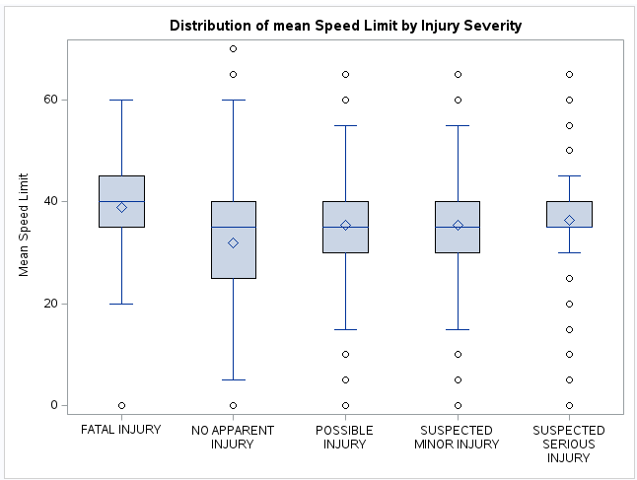

Figure Mean Speed Limit - Injury Severity  
The graph highlights the correlation between speed limits and injury severity. Notably, at the lowest speed limits, individuals generally experience no apparent injuries. However, as the speed limit increases, the likelihood of more severe injuries escalates. A crucial observation is that when speed limits are at their highest, fatal injuries become prevalent. Slightly lowering the speed limit results in individuals facing suspected serious injuries. This underscores a clear trend: higher speed limits are associated with an increased risk of fatal injuries.

## Vehicle movements and Driver at fault

Figure Vehicle movement - Driver at fault

This bar chart visual show count of vehicles movements type moving constant speed and slowing or stopping for driver at fault category which could be yes or no. Interesting that moving constant speed and drivers are fault show highest count 32793 when they are together compared to all bar charts. Then it's moving constant speed and not driver fault 29865. Then follow by not driver fault and slowing or stopping 12926. And last is slowing or stopping and its driver fault 10499. Mostly accident that happen tend to be when people driving and its their fault and most unlikely to happen when people are slowing or stopping and its their fault.

## Vehicle damage by Years

Figure Vehicle damage - Car model Year

This group bar chart show vehicles damages of Disabling or functional each years in accidents. The peakiest year is 2016 for disabling at 7831 and 2017 for functional at 5971. We could see positive trend from 2015 to 2019, however as covid become issues there are spike drop years 2020 which is where quarantine happen and not many people driving which should 5294 for disabling and 3377 for functional this is massive drop. As covid become less issues numbers of vehicles damage start to increase for boths category. At years 2023 show low numbers because this data is update weekly which mean it’s not at full potential yet.

## Count of Injury Severity by Time of Day

Figure Count of Injury Severity - Time of Day

This line plot count of each injury type for each time of the day that occurs. Y axis is count that happen, x axis is time start from 0 and end at 23. Each of line indicates injury types in this data set records which have Fatal injury, no apparent injury, possible injury, suspected minor injury and suspected serious injury. We can see that no apparent injury has highest count follow by possible injury, suspected minor injury, suspected serious injury and fatal injury. This tell people are more likely to be fine incidents as more serious injury are less occurs. Peakiest accident hour is around 8 am in the morning then data trend drop down. This could be due to working hours where people in a rush to work. Lowest would be between 11 pm till mid night as people then start rising this could possibly be due to people start getting sleepy as it very late and lack of sleep. This trend follow for all others category of injury.